METHODS, APPLICATIONS OF IMMOBILIZED ENZYMES
An enzyme derived from an organism or cell culture that catalyses metabolic reaction in living organisms and /or substrate conversions in various chemical reactions. The enzymes are the potential catalyst works in mild temperature, pressure, pH, substrate specificity under suitable reaction conditions and for the production of desired products without any intermediate products as contaminations for these advantages enzyme are used in variety of application such as cosmetics, paper industry, textile industry, food industry, pharmaceutical industry, laundry and in detergents etc.
The biotechnological method of producing enzyme is expensive; hence new methods have been implemented to reduce the cost.
The enzymes have various other limitations such as low stability, highly sensitive to the process conditions and these problems can be overcome by the immobilization techniques.
Immobilized enzymes are being used since 1916, when Nelson and Griffin discovered that invertase when absorbed to charcoal has the ability to hydrolyse the sucrose.
The repeated assay can be done with the immobilized enzyme which reduces the cost of assay and the reuse of enzyme process is also very simple and it can be attained through ultrafiltration technique.
Immobilized proteins/enzymes are used routinely in the medical field, such as in the diagnosis and treatment of various diseases. For example, immobilized antibodies, receptors, or enzymes are used in biosensors and ELISA for the detection of various bioactive substances in the diagnosis of disease states; encapsulated enzymes are also used in bioreactors for the removal of waste metabolites and correction of inborn metabolic deficiency.
ENZYME IMMOBILIZATION METHODS
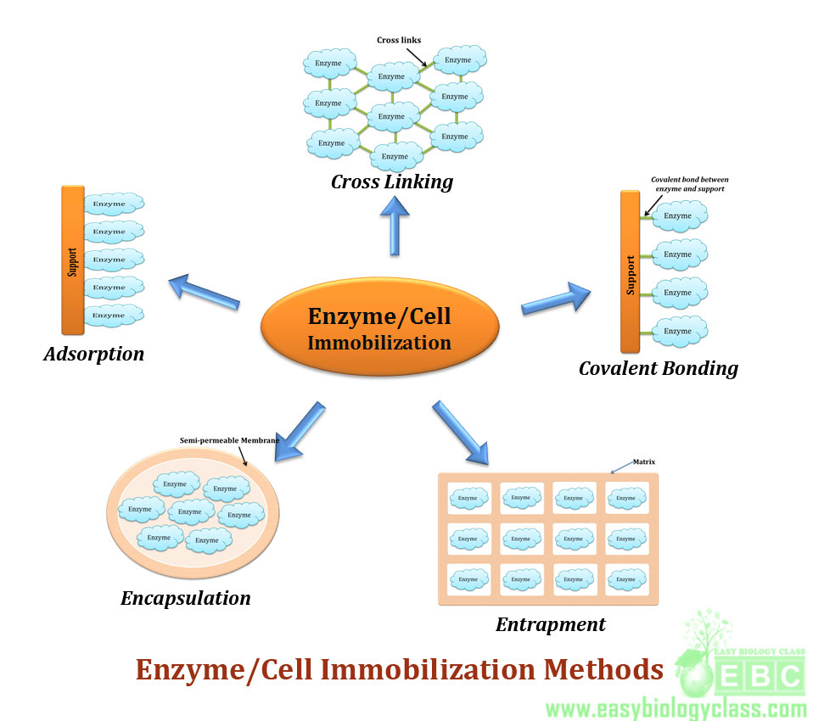
Covalent Binding: Covalent binding is a conventional method for immobilization; it can be achieved by direct attachment with the enzyme and the material through the covalent linkage.The covalent linkage is strong and stable and the support material of enzymes includes polyacrylamide, porous glass, agarose and porous silica. Covalent method of immobilization is mainly used when a reaction process does not require enzyme in the product. The covalent binding is formed between the functional group in the support matrix and the enzyme surface that contains the amino acid residues. The amino acid residues involved in the covalent binding are the sulfhydryl group of cysteine, hydroxyl group of serine and threonine .The attachment between the enzyme and the support material is achieved either through direct linkage or through the spacer arm.
Entrapment: Enzymes are occluded in the synthetic or natural polymeric networks, it is a permeable membrane which allows the substrates and the products to pass, but it retains the enzyme inside the network, the entrapment can be achieved by the gel, fibre entrapping and microencapsulation.The advantage of entrapment of enzyme immobilization is fast, cheap and mild conditions required for reaction process. The disadvantage is that limitation in mass transfer. The support matrix protects the enzymes from microbial contamination, proteins and enzymes in the micro Environment. Microencapsulation method is that the enzyme molecules are capsulated within spherical semipermeable membranes with a selective controlled permeability. This method provides the large surface area between polymeric material and the enzyme. The drawback of this method is inactivation of enzyme during encapsulation.
Adsorption: This is a simple method of preparing an immobilized enzymes and the materials used for adsorption are activated charcoal, Alumina, Ion exchange resins, this method is cheap and easy for use and the disadvantage is a weak binding force between the carrier and the enzyme. This method comes under carrier bound immobilization and the process of immobilization is reversible. Adsorption is the easiest and oldest immobilization techniques. The interaction between the enzyme and the surface of the matrix through weak forces by salt linkage, hydrogen bonds, hydrophobic bonds, ionic bonds and van der waals forces. Based on the charges of the matrix and the protein arrangements the strongly bound, but not distorted enzyme will be formed The advantage of enzyme adsorption is minimum activation step and as a result of minimum activation, no reagents required. It is cheap and easy way of immobilization.
Affinity Binding: The immobilization of enzyme linked to the matrix through the specific interactions. The Two methods are being followed in affinity immobilization. The first method is the activation of the support material which contains the coupled affinity ligand, so that the enzyme will be added. The advantage of this method is the enzyme is not exposed to any harsh chemicals conditions. The second method, the enzyme modified to another molecule which has the ability to bind towards a matrix.
Metal Linked immobilization: In metal linked enzyme immobilization, the metal salts are precipitated over the surface of the carriers and it has the potential to bind with the nucleophilic groups on the matrix. The precipitation of the ion on the carrier can be achieved by heating. This method is simple and the activity of the immobilized enzymes is relatively high (30- 80%). The carrier and the enzyme can be separated by decreasing the pH, hence it is a reversible process .The matrix and the enzyme can be regenerated, by the process.
APPLICATION OF THE IMMOBILIZED ENZYMES
Biomedical Application: immobilized enzymes are used for diagnosis and treatment of diseases in the medical field. .The enzyme encapsulation through the electroporation is a easiest way of immobilization in the biomedical field and it is a reversible process for which enzyme are regenerated.
In food industry,The immobilized enzymes are used for the production of syrups. Immobilized beta-galactosidase used for lactose hydrolysis in whey for the production of bakers yeast. The enzyme galactosidase is linked to resin (food grade) through cross linking. This method is used for the various purposes such as confectionaries and icecreams.
Biodiesel Production: Biodiesel is monoalkyl esters of long chain fatty acids. Biodiesel is produced through triglycerides (vegetable oil, animal fat) with esterification of alcohol (methanol, ethanol) in the presence of the catalyst. Biological production of liquid fuel with lipases has a great consideration with a rapid improvement. Lipase catalyses the reaction with less energy requirements and mild conditions required. But the production of lipase is of high cost, hence the immobilization of lipase which results in repeated use and stability. The immobilization of lipase includes several methods entrapment, encapsulation, cross linking, adsorption and covalent bonding. Adsortion method of immobilization is widely used. In the biological production of biodiesel the methanol inactivates the the lipase, hence the immobilization method is an advantage for the biodiesel production.
Textile Industry: The enzymes such as cellulase, amylase, liccase, pectinase, cutinase etc and these are used for various textile applications such asscouring,biopolishing, desizing, denim finishing, treating wools etc. Among these enzymes cellulase has been widely used. The processing of fabrics with enzymes requires high temperatures and increased pH, the free enzymes does not able to withstand the extreme conditions. Hence, enzyme immobilization for this process able to withstand at extreme and able to maintains its activity for more than 5-6 cycles. PolyMethyl Methacrylateis linked with cellulose covalently. In this method the nanoparticle is synthesized with cellulase as core particle Endoglucanase is a component of Cellulase enzyme, Endoglucanase is microencapsulated with Arabic Gum is a natural polymer with the biodegradable property is used as a matrix for encapsulation of endoglucanase. Encapsulation of endoglucanase prevented it to retain its activity in the presence of detergents.
CONCLUSION
Enzyme immobilization is widely exploited technique in various industries food industry, pharmaceutical industry, bioremediation, detergent industry, textile industry etc. This method is used due to its technical and economical advantage. Large number of enzymes have been immobilized and used in various large scale processes. This Stabilization method lower the cost of the enzymes. Enzyme immobilization provides operational stability to enzymes.

